AI-POWERED MEDICAL LAB REPORT ANALYSIS AND HEALTH INSIGHTS PLATFORM
Design and Implementation
Department of Computer Science and Engineering, TKR College of Engineering and Technology (Autonomous)
Batch A8 (CSE-A) · Academic year 2026-2027
Table 1: Project team
S.No. | Student name | Roll number
1 | BANOTH SWAPNA | 23K91A0528
2 | BEKKAM VARSHITHA | 23K91A0535
3 | A NAVADEEP REDDY | 23K91A0502
4 | BUDIGAM MANOJ | 23K91A0546

Project guide: L.G REDDY
Chapter and section numbers quoted in the text (for example Section 6.6 or Chapter 8) refer to the full project report, 17.Final Document. Figures and tables in this document are numbered from 1.

1. DESIGN

5.1 Architecture
The design follows three rules: keep the pipeline in plain Python modules that can be tested without a web server, keep the web layer thin, and make every failure visible to the user instead of silent. The original Streamlit project already contained the pipeline and the database, so the FastAPI service and the React interface were added on top without changing them.
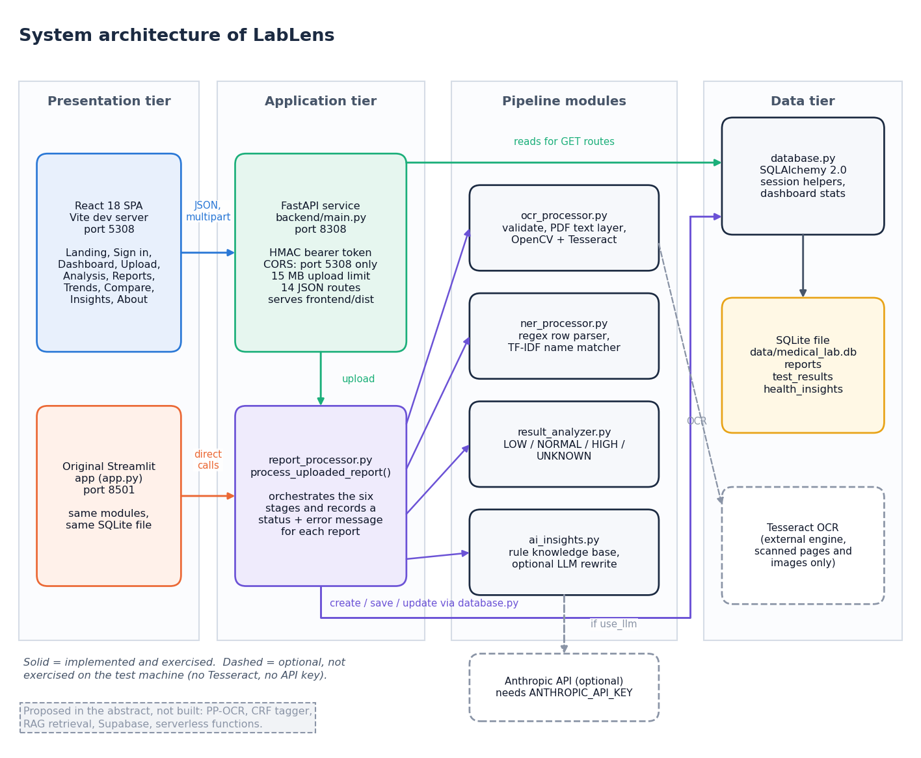
Figure 1: System architecture of LabLens
LabLens has four tiers. In the presentation tier the React single-page application (built with Vite, port 5308) is the main interface, and the original Streamlit application (app.py, port 8501) remains as a second front end that calls the same modules and uses the same SQLite file directly. The application tier holds the FastAPI service in backend/main.py (port 8308), which signs and checks bearer tokens, enforces CORS and the 15 MB upload limit, receives uploads and turns database rows into JSON, and report_processor.py, which coordinates the six pipeline stages and records a status and an error message for each report. The pipeline modules are ocr_processor.py (text extraction), ner_processor.py (row parsing and test-name matching), result_analyzer.py (status rules) and ai_insights.py (explanations). The data tier is the SQLite file data/medical_lab.db, reached through database.py and the ORM classes of models.py. Two services are optional and drawn with dashed outlines: the Tesseract engine, needed only for scanned pages and images, and the Anthropic API, used only to reword explanations; neither was exercised on the test machine. A note on the diagram lists what the abstract proposed but was not built (PP-OCR, a CRF tagger, retrieval, Supabase and serverless functions). After npm run build the API also serves the compiled interface from frontend/dist.

5.2 High-level workflow
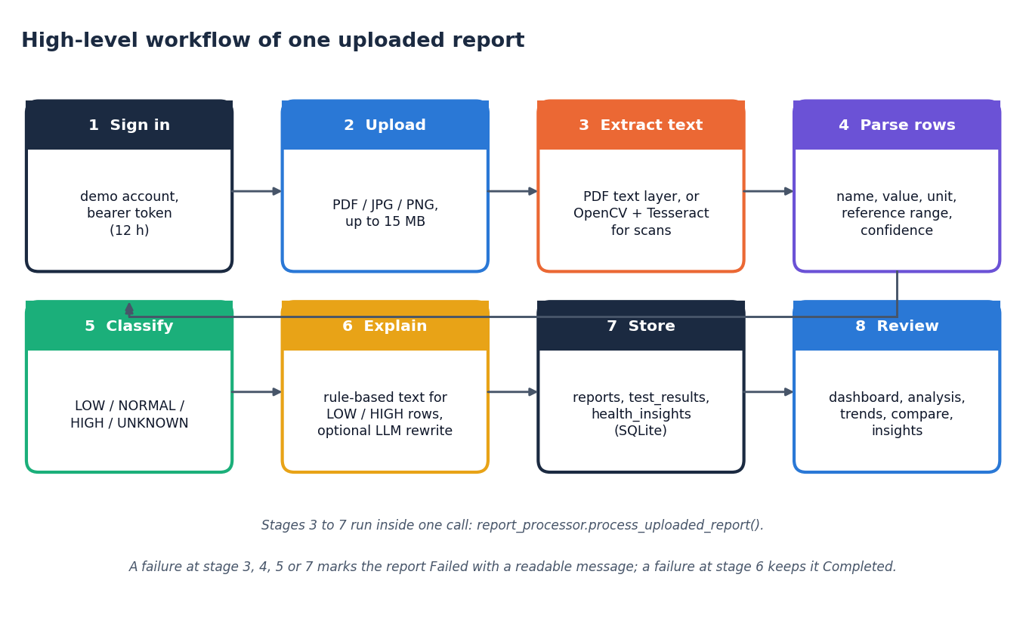
Figure 2: High-level workflow of one report, from upload to review
One report passes through eight steps. The user signs in with the demonstration account (step 1) and uploads a PDF, JPG, JPEG or PNG file of at most 15 MB (step 2). A report row is created at once, so that even a failed upload appears in the report list with its error. Text is then taken from the PDF text layer, or from OpenCV preprocessing followed by Tesseract for scanned pages and images (step 3). The parser turns each line into a candidate row (name, value, unit, reference range, confidence) and snaps the name to a dictionary of 55 test names (step 4). Each row is classified LOW, NORMAL, HIGH or UNKNOWN (step 5), explanations are generated for the LOW and HIGH rows only (step 6), and rows and insights are stored in SQLite (step 7). The user then reviews the results on the dashboard, analysis, trend, comparison and insight screens (step 8). Steps 3 to 7 run inside one call of process_uploaded_report. A failure in the steps that extract, parse, classify or store marks the report Failed with a readable message; a failure in the explanation step leaves the report Completed.

5.3 Data flow diagrams

Level 0
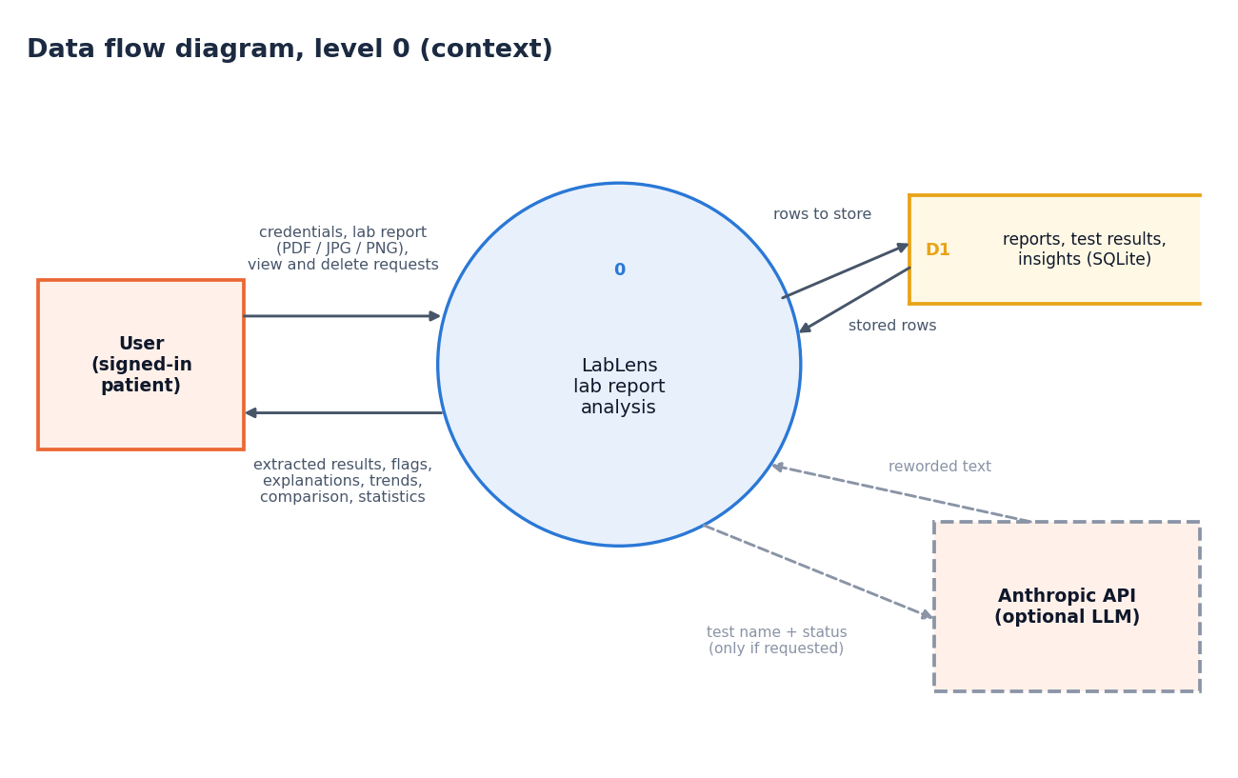
Figure 3: Data flow diagram, level 0 (context diagram)
The context diagram shows LabLens as one process with one external entity, the signed-in user. The user sends credentials, a lab report (PDF, JPG or PNG) and requests to view or delete reports. The system returns the extracted results, their status flags, plain-language explanations, trends, comparisons and statistics. Inside the boundary the process reads and writes one data store, D1, which holds the reports, test results and insights in SQLite. One optional external service, the Anthropic API, receives a test name and status and returns reworded text, but only when the user asks for it and a key is configured. The Tesseract engine is a local program called inside the process and is not drawn at this level.

Level 1
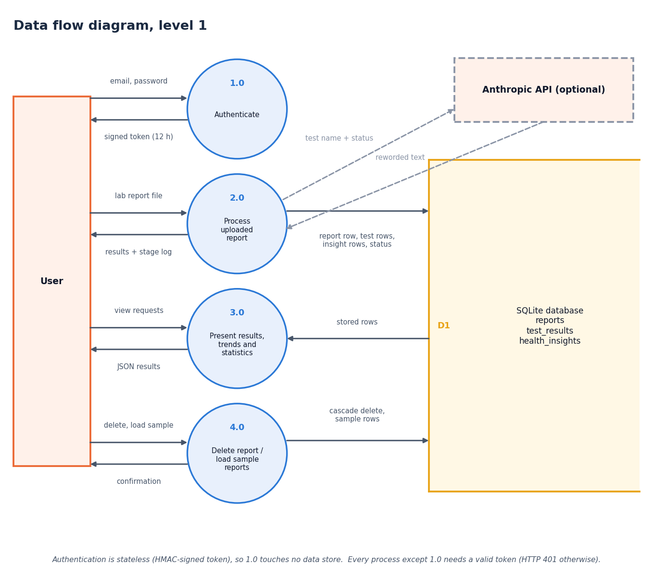
Figure 4: Data flow diagram, level 1
Level 1 splits the system into four processes. Authenticate (1.0) compares the email and password with the configured demonstration account and returns a signed token that is valid for 12 hours. Process uploaded report (2.0) accepts a file and the token, runs the whole pipeline and writes rows to the report, test-result and insight stores (D1, D2, D3); it returns the results and a stage log, and sends a test name and status to the optional Anthropic API only when reworded text was requested. Present results, trends and statistics (3.0) reads the stored rows and returns the dashboard, analysis, trend, comparison and insight data as JSON. Delete or load sample reports (4.0) removes a report with its results and insights by cascade, or adds five synthetic reports. The note under the diagram records that every process except 1.0 needs a valid bearer token and otherwise answers HTTP 401.

Level 2
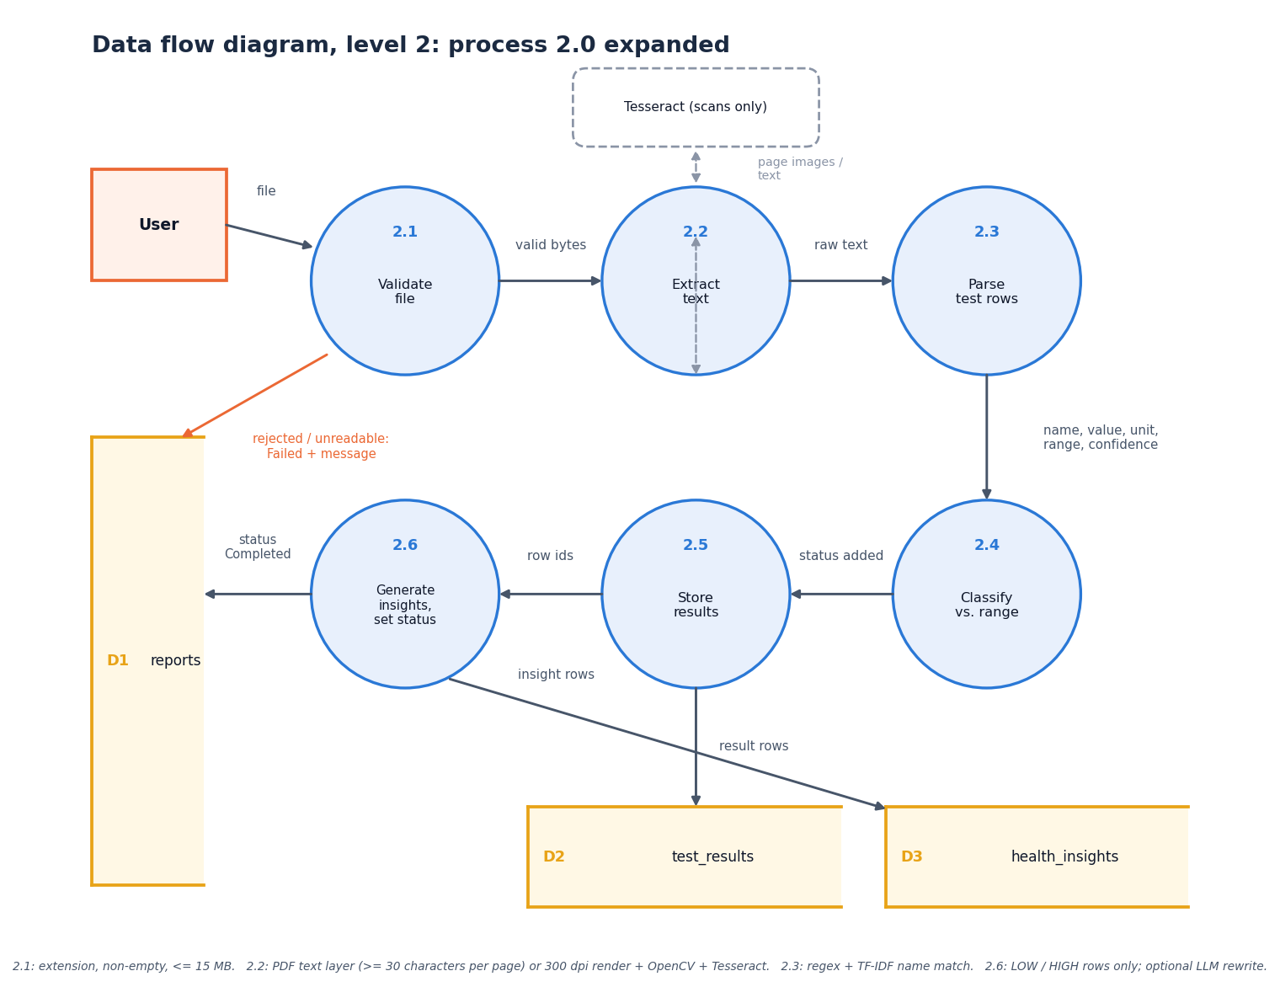
Figure 5: Data flow diagram, level 2: process 2.0 (process uploaded report) expanded
Level 2 expands process 2.0 into the six steps of process_uploaded_report. Validate file (2.1) accepts only pdf, jpg, jpeg and png, a non-empty file and at most 15 MB; a rejected file leads to a Failed report with a message. Extract text (2.2) reads the PDF text layer (at least 30 characters per page) or renders the page at 300 dpi and applies OpenCV preprocessing and Tesseract; an unreadable scan also leads to Failed. Parse test rows (2.3) applies the regular expressions and the TF-IDF name match and yields name, value, unit, range and confidence. Classify against range (2.4) adds the status. Generate insights (2.5) is applied to LOW and HIGH rows only. Store and set status (2.6) writes the result rows (D2), the insight rows (D3) and the report status, raw text and error message (D1).

5.4 UML diagrams

Class diagram
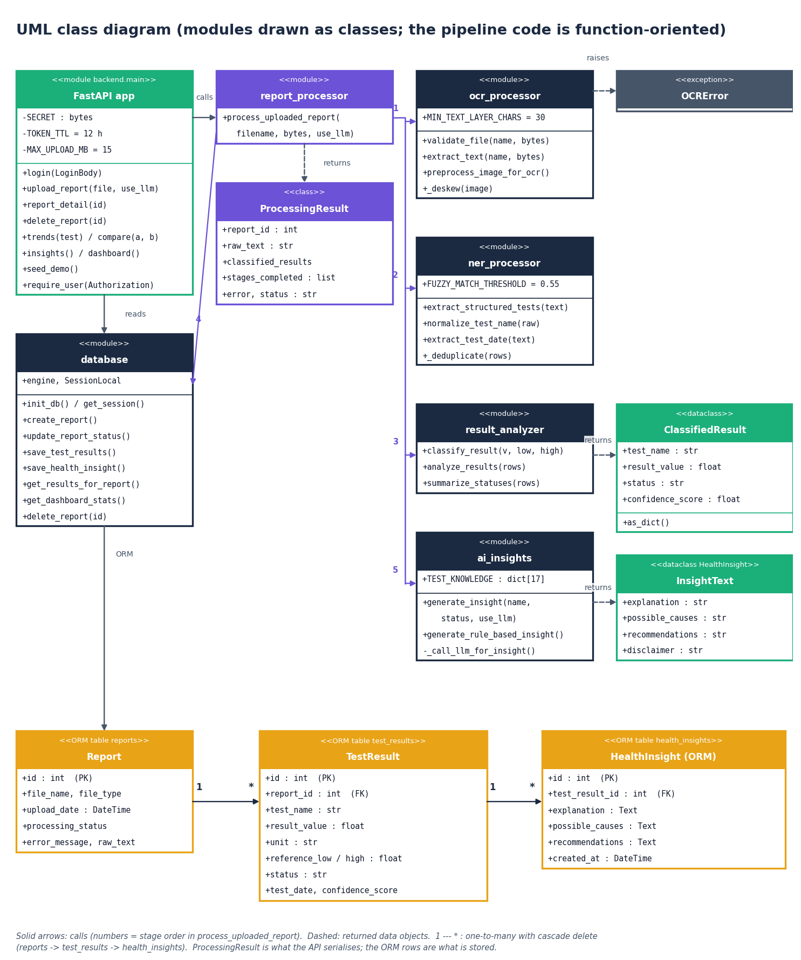
Figure 6: UML class diagram (real classes plus modules drawn as classes)
Most of the pipeline is function-oriented, so the diagram draws each module as a class stereotyped as a module and shows the real classes beside them. The modules are the FastAPI application, report_processor, ocr_processor, ner_processor, result_analyzer, ai_insights and database, each with its constants and public functions. ProcessingResult is the container returned by report_processor; it holds the report identifier, the raw text, the list of classified results, the stages completed, any error and the status. ClassifiedResult is the dataclass returned by result_analyzer. The dataclass HealthInsight of ai_insights.py, which carries the explanation text, is drawn as InsightText so that it is not confused with the ORM class of the same name. The three ORM classes Report, TestResult and HealthInsight (models.py) are linked one to many with cascading delete, and OCRError is the exception raised by the text-extraction stage.

Sequence diagram
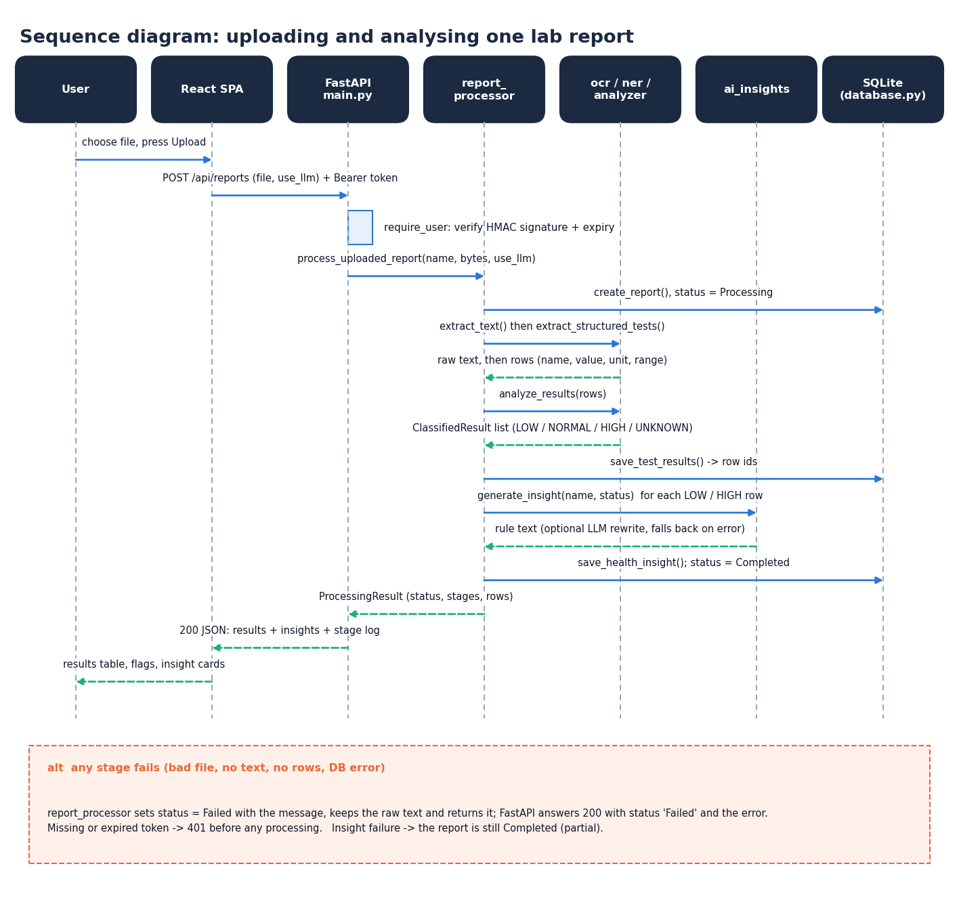
Figure 7: Sequence diagram: uploading and analysing one report
The sequence follows one upload through seven participants. The user chooses a file on the Upload page, which posts it as multipart data to POST /api/reports with the bearer token. The API verifies the HMAC signature and expiry and calls process_uploaded_report, which creates the report row, extracts the text and rows, classifies them, saves them and then asks ai_insights for an explanation of each LOW or HIGH row; the insight is saved and the status becomes Completed. ProcessingResult returns to the API, which answers HTTP 200 with the results, the insights and the stage log, and the page shows the results table, the flags and the insight cards. The alternative box records the failure rules: any failing stage sets the status to Failed with the message and returns it with HTTP 200, a missing or expired token gives 401 before any processing, and an insight failure leaves the report Completed. The whole exchange is one synchronous request.

Use-case diagram
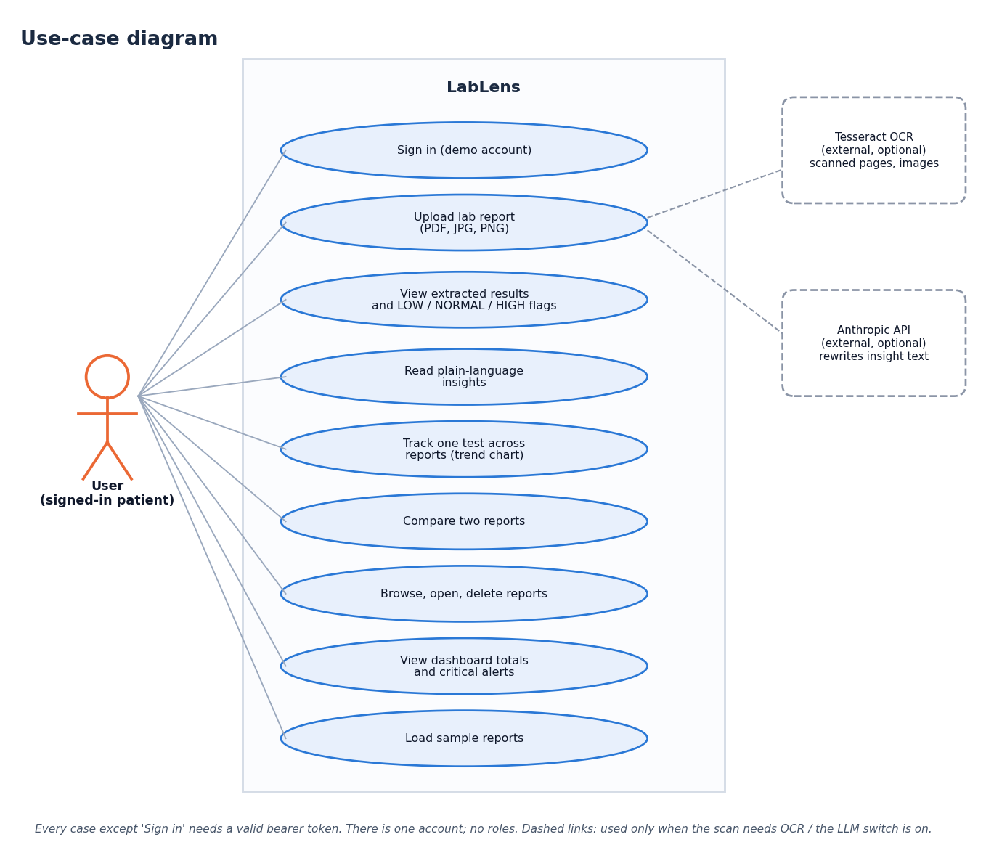
Figure 8: Use-case diagram
There is one actor, the signed-in user, and no roles. The user can sign in with the demonstration account, upload a lab report, view the extracted results with their LOW, NORMAL or HIGH flags, read the plain-language insights, track one test across reports on a trend chart, compare two reports, browse, open and delete reports, view the dashboard totals and critical alerts, and load the five sample reports. Every case except signing in requires a valid token. Two optional external systems appear on the right: the Anthropic API, which extends the insight text when requested, and Tesseract OCR, which the upload case includes for scanned pages and images.

Core algorithm flowchart
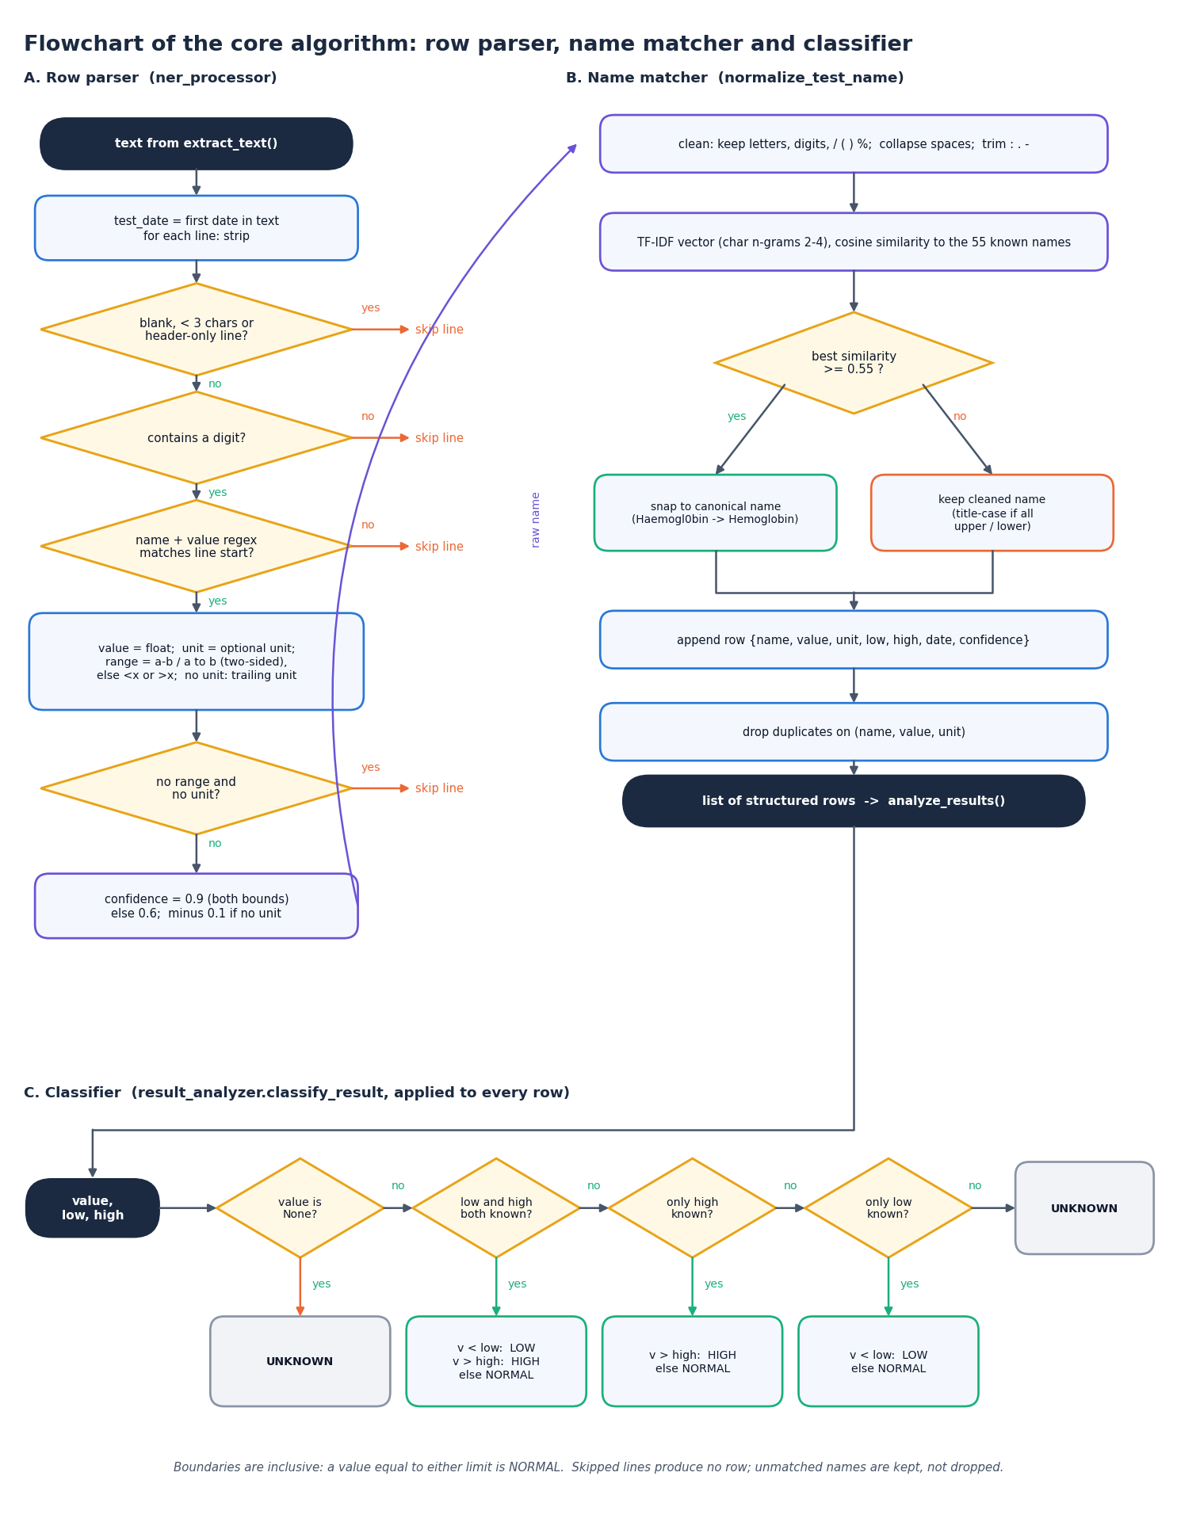
Figure 9: Flowchart of the core algorithm: from a text line to a classified row
The flowchart has three panels that follow the code. Panel A is the row parser of ner_processor.py: the report date is searched once, then each line is skipped if it is blank, shorter than three characters, header-only or without a digit, and must otherwise start with a name followed by a number. The range is searched in the remainder of the line (two-sided first, then one-sided), a unit is taken from the line or from its end, a row with neither range nor unit is skipped, and the others receive a confidence score. Panel B is the name matcher: the name is cleaned, vectorised as character 2-4-grams and compared with the 55 known names; a similarity of at least 0.55 snaps it to the canonical name, otherwise the cleaned name is kept. The row is appended and duplicates on name, value and unit are dropped. Panel C is classify_result: it returns UNKNOWN for a missing value, uses both limits when present, otherwise only the high or only the low limit, and UNKNOWN when there is no limit.

5.5 Database design
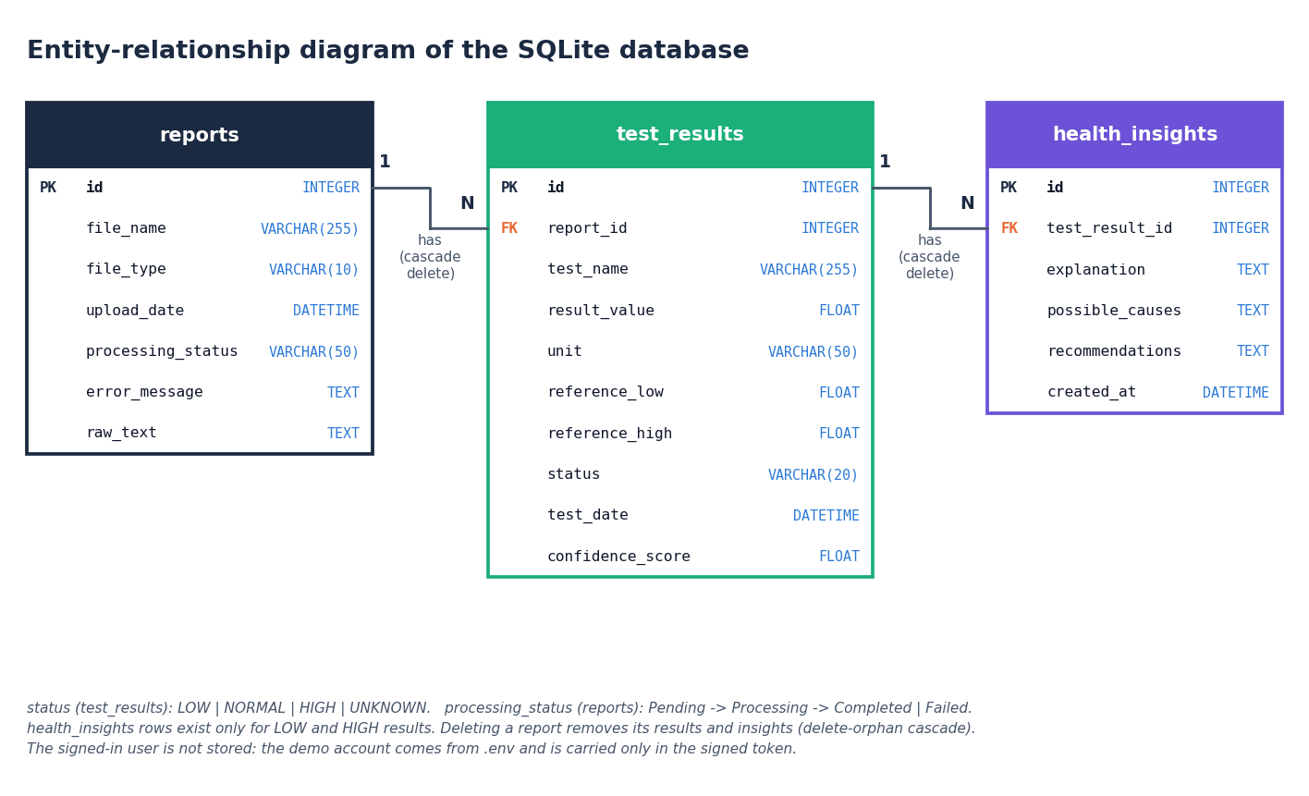
Figure 10: Entity-relationship diagram of the stored data
Persistent data are in three tables. A reports row describes one uploaded file and owns zero or more test_results rows, one for each lab test extracted from it; a test_results row owns zero or more health_insights rows (the code writes one for every LOW or HIGH result). Both relationships are enforced by a foreign key and by the ORM cascade all, delete-orphan, so deleting a report removes its results and their insights. The demo user is not an entity: the account is configured through environment variables and exists only inside the signed token, so the database holds one shared library.
Table 2: Table reports
Column | Type | Constraint | Meaning
id | INTEGER | Primary key, auto-increment | Report number shown in the interface
file_name | VARCHAR(255) | NOT NULL | Name of the uploaded file
file_type | VARCHAR(10) | nullable | pdf, jpg, jpeg or png
upload_date | DATETIME | default UTC now | Upload time (naive UTC); the x-axis of every trend
processing_status | VARCHAR(50) | default Pending | Pending, Processing, Completed or Failed
error_message | TEXT | nullable | Reason shown to the user when the status is Failed
raw_text | TEXT | nullable | Full extracted text, kept so a failure can be inspected

Table 3: Table test_results
Column | Type | Constraint | Meaning
id | INTEGER | Primary key, auto-increment | Result identifier
report_id | INTEGER | Foreign key to reports.id, NOT NULL | Owning report
test_name | VARCHAR(255) | NOT NULL | Normalised test name; trends match on this exact string
result_value | FLOAT | nullable | Measured value
unit | VARCHAR(50) | nullable | Unit as printed, or null if none was recognised
reference_low | FLOAT | nullable | Lower limit; null for a one-sided upper limit
reference_high | FLOAT | nullable | Upper limit; null for a one-sided lower limit
status | VARCHAR(20) | nullable | LOW, NORMAL, HIGH or UNKNOWN
test_date | DATETIME | nullable | Date found in the report text, if any
confidence_score | FLOAT | default 0.0 | Extraction confidence, 0.1 to 0.9

Table 4: Table health_insights
Column | Type | Constraint | Meaning
id | INTEGER | Primary key, auto-increment | Insight identifier
test_result_id | INTEGER | Foreign key to test_results.id, NOT NULL | The abnormal result explained
explanation | TEXT | nullable | What the test measures and how the result was flagged
possible_causes | TEXT | nullable | General, non-diagnostic possible causes
recommendations | TEXT | nullable | Suggestion to discuss the result with a clinician
created_at | DATETIME | default UTC now | Creation time; the newest insight per result is read

The tables are created by init_db() with Base.metadata.create_all, so a fresh checkout needs no migration. Access goes through SQLAlchemy sessions that commit on success and roll back on any exception, which removes string-built SQL and with it injection through file names or test names. There are no secondary indexes and no unique constraint: the volumes of a personal library are small, and a repeated upload simply creates a second report. The schema has no user column, because the product keeps one shared library.

5.6 Module design
Each pipeline stage is one module with one public entry point, and each module imports only the stages before it. This is what lets the unit tests of Chapter 7 call extract_structured_tests or classify_result directly with no database and no server.
Table 5: Modules, sizes and responsibilities
Module | Lines | Responsibility | Key functions
ocr_processor.py | 225 | Upload validation, PDF text layer, OpenCV preprocessing, Tesseract | validate_file, extract_text, preprocess_image_for_ocr
ner_processor.py | 289 | Row parsing, test-name matching, date and patient name | extract_structured_tests, normalize_test_name, extract_test_date
result_analyzer.py | 100 | Status rules and summary counts | classify_result, analyze_results, summarize_statuses
ai_insights.py | 270 | Knowledge base, rule-based and optional LLM explanations | generate_insight, generate_rule_based_insight
report_processor.py | 148 | Pipeline coordination and failure handling | process_uploaded_report
database.py | 251 | Engine, sessions, CRUD helpers, dashboard totals | create_report, save_test_results, get_results_by_test_name, get_dashboard_stats
models.py | 97 | ORM tables | Report, TestResult, HealthInsight
backend/main.py | 352 | FastAPI routes, token authentication, JSON serialisers | 14 routes (Section 5.7)
backend/demo_data.py | 98 | Five synthetic sample reports drawn as PDFs | render_pdf, seed_demo_reports
app.py | 523 | Original Streamlit interface | Upload, analysis, history, trends, comparison pages
frontend/src/pages/ | 1,756 | Eleven React pages | Landing, Login, Dashboard, Upload, Analysis, Reports, Trends, Compare, Insights, About, NotFound

5.7 API design
The API is JSON over HTTP. Errors use the FastAPI body {"detail": "message"}; the interface shows the message as it is, so every message was written for the user: for example "Please select two different reports." The status codes are 401 for a missing, forged or expired token, 404 for an unknown report, 400 when the two reports to compare are the same, 409 when sample reports are requested for a non-empty library, and 422 for a malformed request. A report that cannot be processed is not an HTTP error: POST /api/reports answers 200 with status set to Failed and the reason in error, because the failure is a normal outcome of a user-supplied file and the report is kept in the list.
Table 6: REST endpoints
Method | Path | Token | Purpose
GET | /api/health | No | Liveness check; returns {"status": "ok"}
GET | /api/config | No | Disclaimer, accepted extensions, dictionary names, size limit, LLM availability, demo e-mail and password
POST | /api/auth/login | No | Checks the demo account; returns a signed token and the user
GET | /api/auth/me | Yes | The signed-in user, used to restore a session
GET | /api/dashboard | Yes | Totals and the ten most recent reports with test and abnormal counts
GET | /api/reports | Yes | All reports, newest first, with counts
POST | /api/reports | Yes | Multipart file and use_llm; runs the pipeline and returns status, stages, results and insights
GET | /api/reports/{id} | Yes | One report with its results, insights and the first 5,000 characters of raw text
DELETE | /api/reports/{id} | Yes | Deletes the report, its results and insights
GET | /api/tests | Yes | Distinct test names on file, for the trend selector
GET | /api/trends?test= | Yes | Values of one test across reports in upload order, with direction
GET | /api/compare?a=&b= | Yes | Tests common to two reports, with the change (second minus first)
GET | /api/insights | Yes | Every LOW or HIGH result with its insight, newest report first
POST | /api/demo/seed | Yes | Loads five synthetic reports through the real pipeline, only into an empty library

5.8 User interface design
The interface follows the Depth Studio design kit: layered dark surfaces with soft elevation, an emerald accent, the Sora, Inter and JetBrains Mono typefaces, and a light theme chosen with a toggle whose choice is stored in the browser (ll-theme). Status carries meaning through colour and text: green for Normal, amber for Low and red for High, each badge spelling the word, so colour is never the only signal. Every page repeats the reminder "Educational tool - not a medical device" in the header, and pages that show results end with the full medical disclaimer returned by /api/config.
The shell is a fixed sidebar with eight entries and a link back to the landing page; on narrow screens it becomes a drawer. Routes are code-split and loaded lazily, with a skeleton shown while a page loads. Every list has an empty state that says what to do next, and the empty dashboard offers to load the sample reports. Every request that can fail shows an error panel naming the problem (for example that the backend on port 8308 cannot be reached) with a Try again button.
Table 7: Screens and the screenshots that show them (Chapter 8 and Appendix C)
Screen and route | Screenshot nos. | Content
Landing / | 01, 02 | Public introduction with a three-dimensional hero scene (static image when motion is reduced), how it works, disclaimer
Sign in /login | 03 | Demo credentials with a one-click sign-in button
Dashboard /app | 04, 13 | Report, test, normal, abnormal and critical totals, critical alert banner, recent reports, results by status; empty state with a button to load sample reports
Upload /app/upload | 05, 06 | Drop area, accepted formats and size, optional LLM switch, six-step progress, results table after processing
Analysis /app/analysis/:id | 07 | Report selector, counts, filterable results table, insight cards for abnormal results, raw text, disclaimer
My reports /app/reports | 08 | Searchable list with status, counts, expandable results and a confirmed delete
Trends /app/trends | 09 | Test selector, line chart with reference band, direction note, table of all values
Compare /app/compare | 10 | Two report selectors, tests in common, change column, bar chart grouped by unit
Insights /app/insights | 11 | Every abnormal result with its explanation, status tabs and search
About /app/about | 12 | What the product does, pipeline, limits, disclaimer

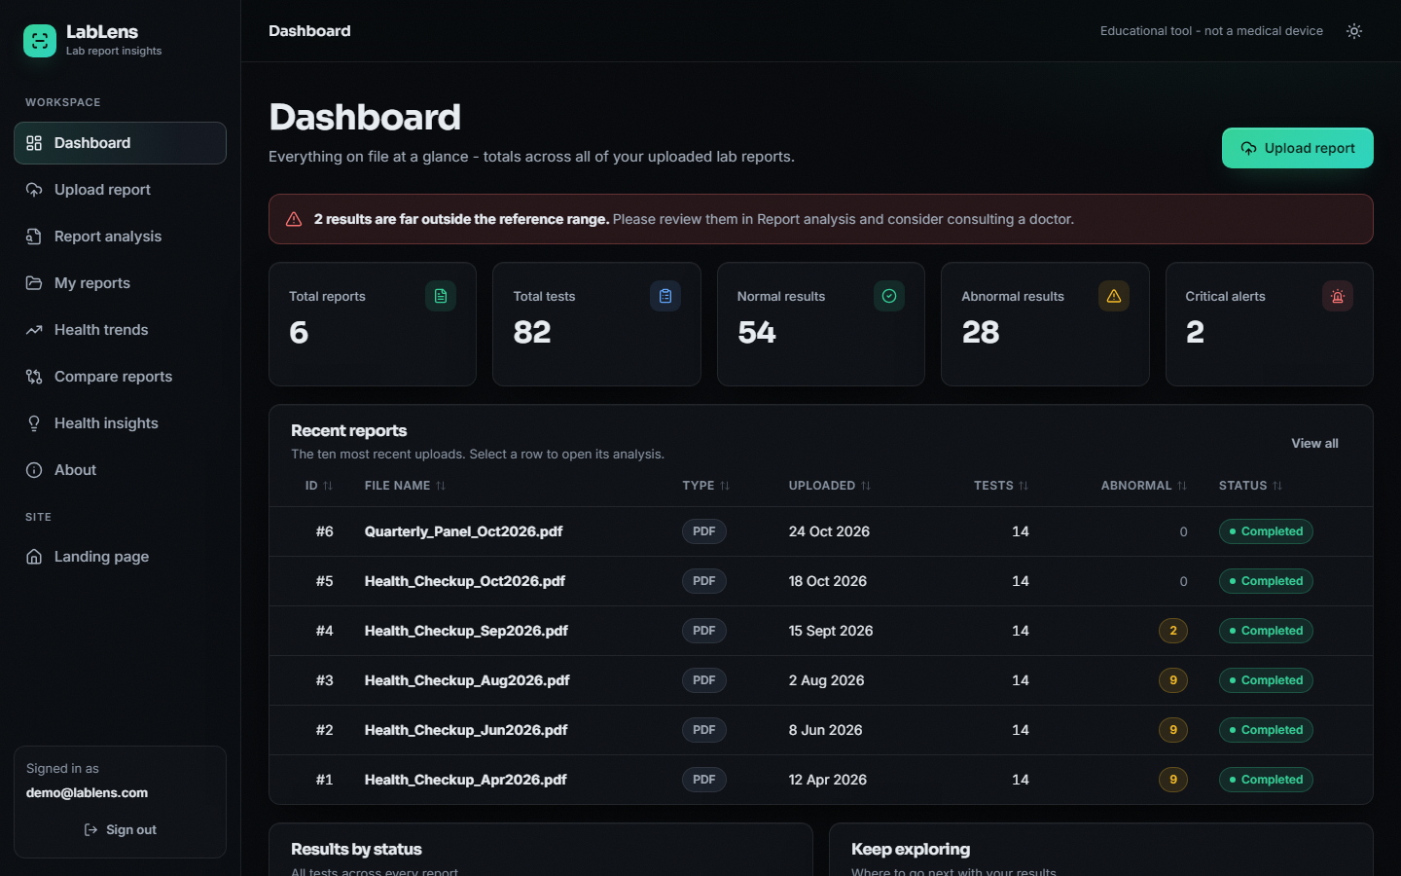
Figure 11: The dashboard: totals, a critical-result banner and the six reports of the demonstration library
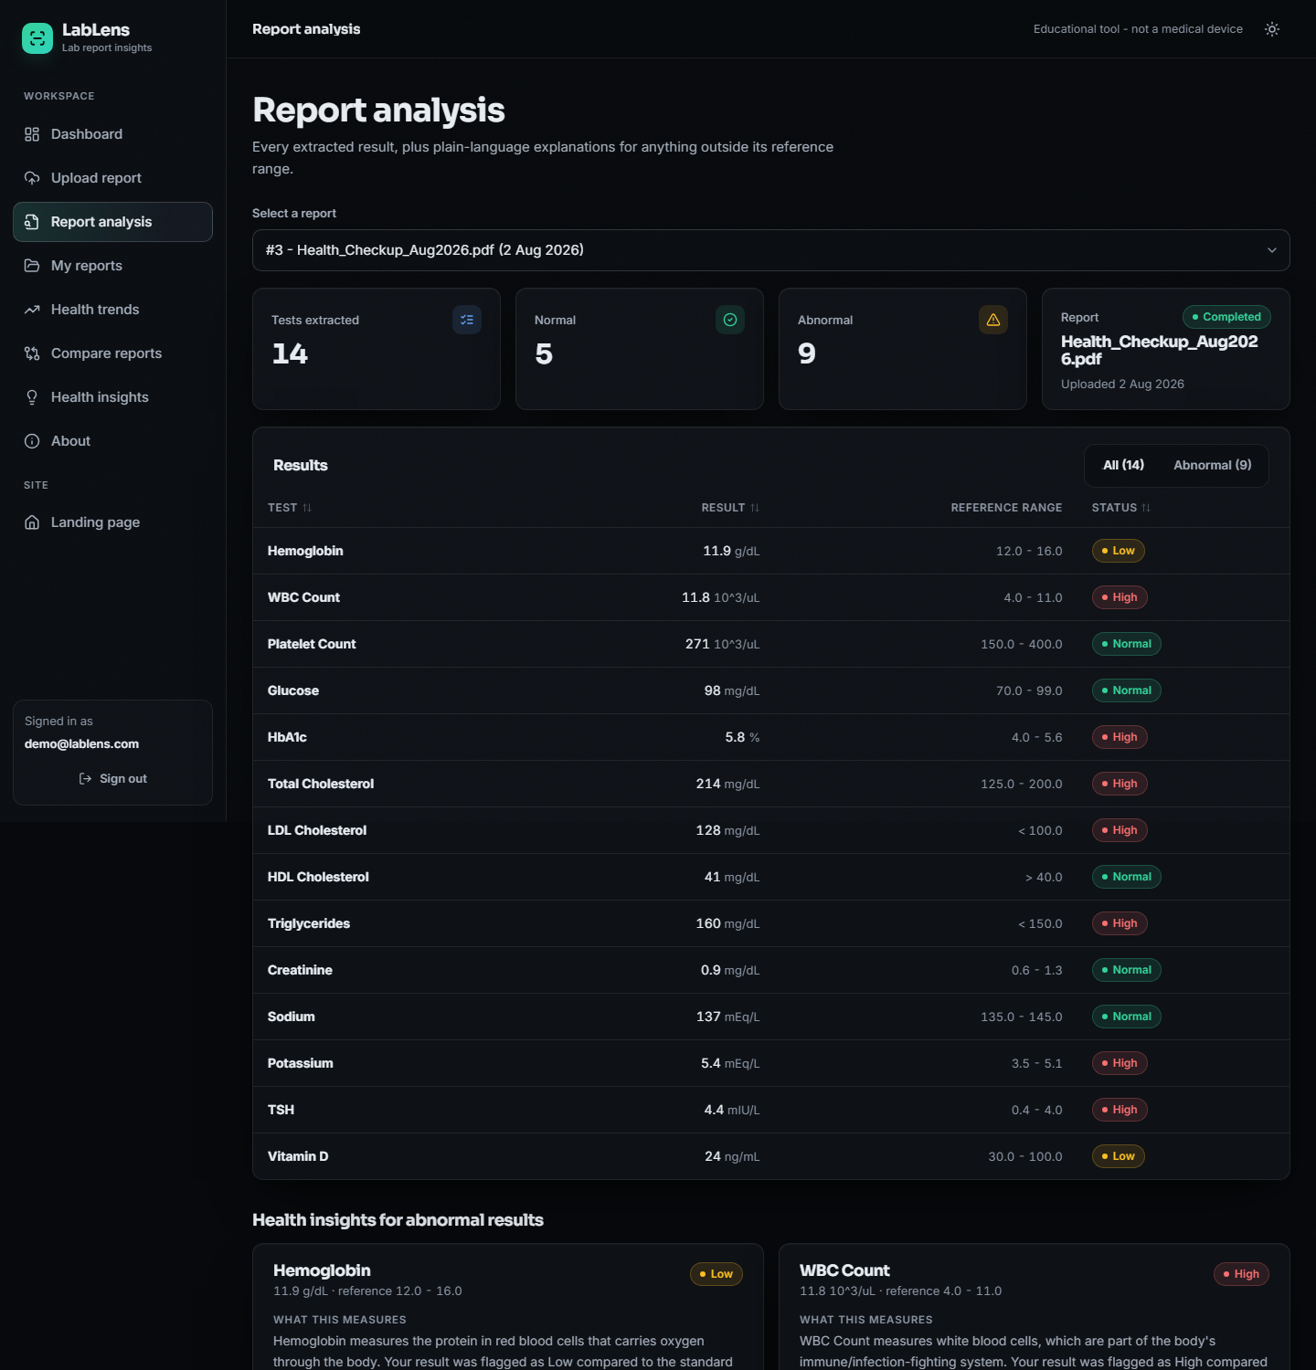
Figure 12: The report analysis screen: extracted rows with status badges and insight cards (top of the page)
Accessibility was designed in: a skip link is the first tab stop, every control has a visible focus ring and a label, the navigation drawer closes with the Escape key, loading regions are marked busy, and motion is reduced when the operating system asks for it (the landing page then shows a static image instead of the three-dimensional scene). Chapter 7 lists the automated checks.

5.9 Security design
The product handles health data, so the design states what it protects and what it does not. Access is gated by a signed token (HMAC-SHA256, 12 hours) sent in the Authorization header; every route except health, configuration and login requires it. Uploads are limited to four extensions and 15 MB, all SQL goes through the ORM, and cross-origin requests are accepted only from the two local interface origins. The design does not provide per-user data separation, HTTPS, password hashing (there is one configured demonstration account) or an audit log, and the configuration route returns the demonstration password so that the sign-in page can offer a one-click button. These are limits of a demonstration build; Chapter 6 gives the controls in detail and Chapter 10 the steps needed for real use.

2. IMPLEMENTATION

6.9 Application architecture
backend/main.py creates the FastAPI application [21] and calls db.init_db() at import, which creates the tables if they do not exist. It adds the CORS middleware, defines the token helpers and the fourteen routes, and imports process_uploaded_report from the pipeline; there is no pipeline logic in the web layer. The Streamlit application app.py still runs against the same SQLite file. If frontend/dist exists (after npm run build) the API also serves the compiled single-page application and falls back to index.html for any non-API path, so the product can run as one process on port 8308.
The interface is a React 18 single-page application built with Vite 5, react-router 6 and Recharts [22]. During development the Vite server on port 5308 proxies /api to port 8308, so the browser sees one origin. Pages are loaded lazily. lib/api.js wraps fetch, turns every error response into an ApiError that carries the server's message, and uses an XMLHttpRequest for uploads because fetch cannot report upload progress. A 401 anywhere clears the stored token and returns the user to the sign-in page. A small hook, useAsync, gives every page the same loading, error and retry behaviour.
The upload route runs the whole pipeline inside the request. This is simple and, for a one-page report, fast: the end-to-end pipeline including the database takes a median of 53 ms and the HTTP upload a median of 210 ms. A long scanned report would block the worker for as long as OCR takes, which is why a job queue is listed as future work.

6.10 API design and the upload route
Section 5.7 lists the routes. The upload route accepts file and use_llm, calls the pipeline, and returns the status, the stages completed, the error text, the first 5,000 characters of extracted text and, for a completed report, every result with its insight. The trend route returns the points of one test in upload order and a direction: increasing, decreasing or stable by comparing only the last value with the first. The compare route intersects the test names of two reports and returns the change as the second value minus the first, rounded to two decimals.
@app.post("/api/reports")
def upload_report(file: UploadFile = File(...), use_llm: bool = Form(False), _: str = Depends(require_user)):
data = file.file.read()
result = process_uploaded_report(file.filename or "upload", data, use_llm_insights=use_llm)
out = {"status": result.status, "report_id": result.report_id,
"stages_completed": result.stages_completed, "error": result.error,
"raw_text": result.raw_text[:5000], "results": []}
if result.status == "Completed" and result.report_id is not None:
out["results"] = [result_dict(r, with_insight=True) for r in db.get_results_for_report(result.report_id)]
return out

6.11 Security and error handling
Table 8: Threats, faults and the controls in the code
Threat or fault | Control
Anonymous access | Every route except health, configuration and login depends on require_user, which reads the bearer token and answers 401
Token forgery or tampering | Token = base64url(JSON with subject and expiry) + "." + base64url(HMAC-SHA256 of that body with JWT_SECRET), compared with hmac.compare_digest; expires after 12 hours
Credential guessing by timing | E-mail and password are compared with hmac.compare_digest
Hostile uploads | Extension whitelist (pdf, jpg, jpeg, png), empty-file check and a 15 MB limit in validate_file; undecodable files raise OCRError and the report is marked Failed
SQL injection | All access through the SQLAlchemy ORM with bound parameters
Cross-site requests | CORS allows only http://localhost:5308 and http://127.0.0.1:5308
Failure at any pipeline stage | The report row is created first; each stage is wrapped so that a failure sets status Failed with a readable message and keeps the raw text; an insight failure only shortens the stage list
Secrets in source control | .env is ignored by git; .env.example documents JWT_SECRET, the ports and the optional API key
Missing optional services | No Tesseract: a clear message for images, PDFs unaffected. No API key: the LLM switch is disabled and rule-based text is used

Weaknesses that remain: the token is kept in the browser's localStorage, which a script injected into the page could read; the default signing secret is a published placeholder until .env is edited; there is one shared account and one shared library; the configuration route returns the demonstration password for the sign-in page; and traffic is plain HTTP on the local machine.

6.12 Installation and execution
run.bat reads BACKEND_PORT (8308) and FRONTEND_PORT (5308) from .env, checks that Python and Node.js are on the path, creates backend\.venv and installs backend\requirements.txt when the environment is missing or cannot import the required packages, runs npm install in frontend on first use, warns if Tesseract is absent, starts the API with uvicorn and the interface with npm run dev, and opens the browser. Closing the two console windows stops the product. Appendix B gives the manual commands and the troubleshooting table.

3. KEY CODE WALK-THROUGHS
The excerpts below are taken from the repository by the build script, so they are the code that was tested and measured.

3.1 Reading one line of a report (`ner_processor.py`)
A row is recognised in two stages. The first pattern requires a name followed by a number and optionally a unit; the rest of the line is then searched for a two-sided range, then a one-sided limit, then a trailing unit. Keeping the stages separate lets the range appear in any common format without one very long pattern.
_NAME_VALUE_PATTERN = re.compile(
r"^\s*(?P<name>[A-Za-z][A-Za-z0-9()/,.\- ]{1,60}?)\s*[:\-]?\s+"
r"(?P<value>-?\d+\.?\d*)\s*"
r"(?P<unit>" + _UNIT_RE + r")?",
re.IGNORECASE,
)

# Stage 2a: two-sided numeric range, e.g. "12-16", "12 - 16", "12 to 16".
_TWO_SIDED_RANGE_PATTERN = re.compile(
r"(?P<low>-?\d+\.?\d*)\s*(?:-|to|–|—)\s*(?P<high>-?\d+\.?\d*)"
)

# Stage 2b: one-sided range, e.g. "<5", ">10", "< 200".
_ONE_SIDED_RANGE_PATTERN = re.compile(r"([<>])\s*(-?\d+\.?\d*)")

# Trailing unit that may appear after the range, e.g. "12-16 g/dL".
_TRAILING_UNIT_PATTERN = re.compile(r"(" + _UNIT_RE + r")\s*\)?\s*$", re.IGNORECASE)

The extraction loop applies the patterns line by line, assigns a confidence of 0.9 when both limits were found and 0.6 otherwise (minus 0.1 without a unit) and discards a row that has neither a range nor a unit. That last rule is why a slash-formatted date is rejected, and why a hyphenated one is not.
for raw_line in text.splitlines():
line = raw_line.strip()
if not line or len(line) < 3:
continue
if _NOISE_LINE_RE.match(line):
continue
# Skip lines with no digit at all -- can't be a result row
if not re.search(r"\d", line):
continue

match = _NAME_VALUE_PATTERN.match(line)
if not match:
continue

name_raw = match.group("name")
try:
value = float(match.group("value"))
except (TypeError, ValueError):
continue

unit = match.group("unit") or ""
remainder = line[match.end():]

# A bare "Test 220" line with nothing else after it isn't useful
# enough to trust unless it at least has a unit -- otherwise it's
# likely a mis-parsed header/noise line.
low_val = high_val = None

range_match = _TWO_SIDED_RANGE_PATTERN.search(remainder)
if range_match:
low_val = float(range_match.group("low"))
high_val = float(range_match.group("high"))
else:
low_val, high_val = _parse_one_sided_range(remainder)

if not unit:
trailing_unit_match = _TRAILING_UNIT_PATTERN.search(remainder)
if trailing_unit_match:
unit = trailing_unit_match.group(1)

confidence = 0.9 if (low_val is not None and high_val is not None) else 0.6
if not unit:
confidence -= 0.1
if low_val is None and high_val is None and not unit:
# Too little structure to be confident this is a real test row
continue

results.append({
"test_name": normalize_test_name(name_raw),
"result_value": value,
"unit": unit.strip() if unit else None,
"reference_low": low_val,
"reference_high": high_val,
"test_date": test_date,
"confidence_score": round(max(confidence, 0.1), 2),
})

return _deduplicate(results)

3.2 Normalising a test name (`ner_processor.py`)
def normalize_test_name(raw_name: str) -> str:
"""
Clean an OCR-extracted test name and, if it's a close match to a known
lab test, snap it to the canonical spelling/casing. Otherwise return
the cleaned raw name unchanged (extraction still succeeds for tests
outside our reference dictionary).
"""
cleaned = re.sub(r"[^A-Za-z0-9/() %]", " ", raw_name)
cleaned = re.sub(r"\s+", " ", cleaned).strip(" :.-")
if not cleaned:
return raw_name.strip()

try:
vec = _TEST_NAME_VECTORIZER.transform([cleaned])
sims = cosine_similarity(vec, _KNOWN_NAME_VECTORS)[0]
best_idx = sims.argmax()
if sims[best_idx] >= FUZZY_MATCH_THRESHOLD:
return KNOWN_TEST_NAMES[best_idx]
except Exception:
pass

# Title-case fallback for unmatched-but-plausible test names
return cleaned.title() if cleaned.isupper() or cleaned.islower() else cleaned

The dictionary vectors are computed once at import. A name is snapped only when the best cosine similarity reaches 0.55; below that, the cleaned name is kept, which is how unseen tests survive and also how a close-but-different test can be renamed.

3.3 Classification (`result_analyzer.py`)
def classify_result(result_value, reference_low, reference_high) -> str:
"""Pure classification function -- returns one of LOW/NORMAL/HIGH/UNKNOWN."""
if result_value is None:
return "UNKNOWN"

if reference_low is not None and reference_high is not None:
if result_value < reference_low:
return "LOW"
if result_value > reference_high:
return "HIGH"
return "NORMAL"

if reference_high is not None: # only an upper bound is known
return "HIGH" if result_value > reference_high else "NORMAL"

if reference_low is not None: # only a lower bound is known
return "LOW" if result_value < reference_low else "NORMAL"

return "UNKNOWN"

3.4 Running the stages for one report (`report_processor.py`)
The report row is created first, so that a failure at any later stage leaves a visible Failed record with its error message and the text already extracted.
# 2. OCR / text extraction
try:
raw_text = extract_text(filename, file_bytes)
result.raw_text = raw_text
result.stages_completed.append("Text extraction")
except OCRError as exc:
db.update_report_status(report_id, "Failed", error_message=str(exc))
result.error = str(exc)
result.status = "Failed"
return result
except Exception as exc:
msg = f"Unexpected error during text extraction: {exc}"
db.update_report_status(report_id, "Failed", error_message=msg)
result.error = msg
result.status = "Failed"
return result

# 3. NER / structured extraction
try:
structured_tests = extract_structured_tests(raw_text)
result.stages_completed.append("Test-value extraction")
except Exception as exc:
msg = f"Unexpected error during test extraction: {exc}"
db.update_report_status(report_id, "Failed", error_message=msg, raw_text=raw_text)
result.error = msg
result.status = "Failed"
return result

if not structured_tests:
msg = (
"Text was extracted, but no recognizable lab test rows were found. "
"The report format may not be supported yet, or the scan quality may be too low."
)
db.update_report_status(report_id, "Failed", error_message=msg, raw_text=raw_text)
result.error = msg
result.status = "Failed"
return result

3.5 Trends and comparison (`backend/main.py`)
@app.get("/api/trends")
def trends(test: str = Query(...), _: str = Depends(require_user)):
rows = db.get_results_by_test_name(test)
points = [
{
"report_id": report.id,
"file_name": report.file_name,
"date": iso(report.upload_date),
"value": tr.result_value,
"reference_low": tr.reference_low,
"reference_high": tr.reference_high,
"unit": tr.unit,
"status": tr.status,
}
for tr, report in rows
]
direction = None
values = [p["value"] for p in points if p["value"] is not None]
if len(values) >= 2:
direction = "increasing" if values[-1] > values[0] else "decreasing" if values[-1] < values[0] else "stable"
return {"test": test, "points": points, "direction": direction}

The trend direction is decided by comparing only the last and first value; a rise followed by a fall back to the start is reported as stable. This is simple and visible, and it is listed as a limitation.

4. IMPLEMENTATION DECISIONS AND THEIR REASONS
Each decision below was taken for a stated reason, and the measured consequence is given where one exists.
Table 9: Implementation decisions
Decision | Alternative | Reason | Measured consequence
Regex line parser for the four fields | trained CRF tagger as in the abstract | no labelled training data exists; a parser is deterministic and fast | F1 about 0.98 on single-line layouts (0.916 over all eight); fails on cell-per-line tables
TF-IDF character n-grams to snap names | difflib ratio; exact match; learned embedding | one sparse product, vectors computed once | worse than difflib under noise (0.890 against 0.981 at 10%)
Keep unmatched names as read | reject unknown tests | any lab test should still be extracted | unseen tests are kept, but some are renamed
Reference range read from the report itself | built-in range table | ranges depend on laboratory, age and sex | status accuracy 99.9% when the range is read correctly
Rule-based explanations, optional LLM rewrite | RAG with a vector store | offline, deterministic and safe by default; no corpus to license | 30.9% of tests have specific text; no citations
SQLite through SQLAlchemy | Supabase PostgreSQL | no account or network needed; one file | single-user only; no row-level security
FastAPI + React, original Streamlit app kept | Streamlit only | a faster, richer interface over the same modules | API reads under 17 ms; upload 210 ms
HMAC-signed 12-hour token, one demo account | full user registration | the original product had no login; enough to protect the API in a demo | no per-user separation
Sample reports rendered as PDFs and sent through the pipeline | hand-inserted database rows | the demo data then exercises the real code path | screens show genuine pipeline output
Limits inclusive in classification | exclusive limits | a value on the printed limit is within the range | 20,000-case check, 0 disagreements

